Experiment=7
Manage Browser Security
Step1: Click on windows and search for Google chrome
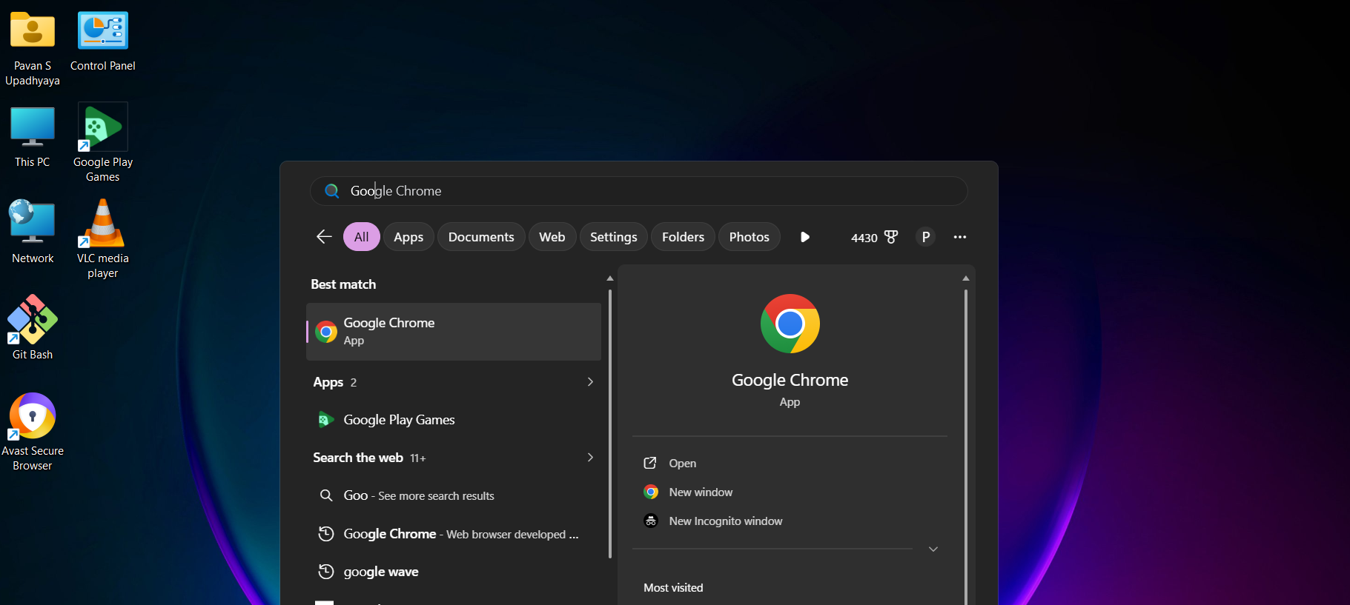
Sep2: At the top right corner click on 3 dots select settings


Step3: In settings click on privacy and security
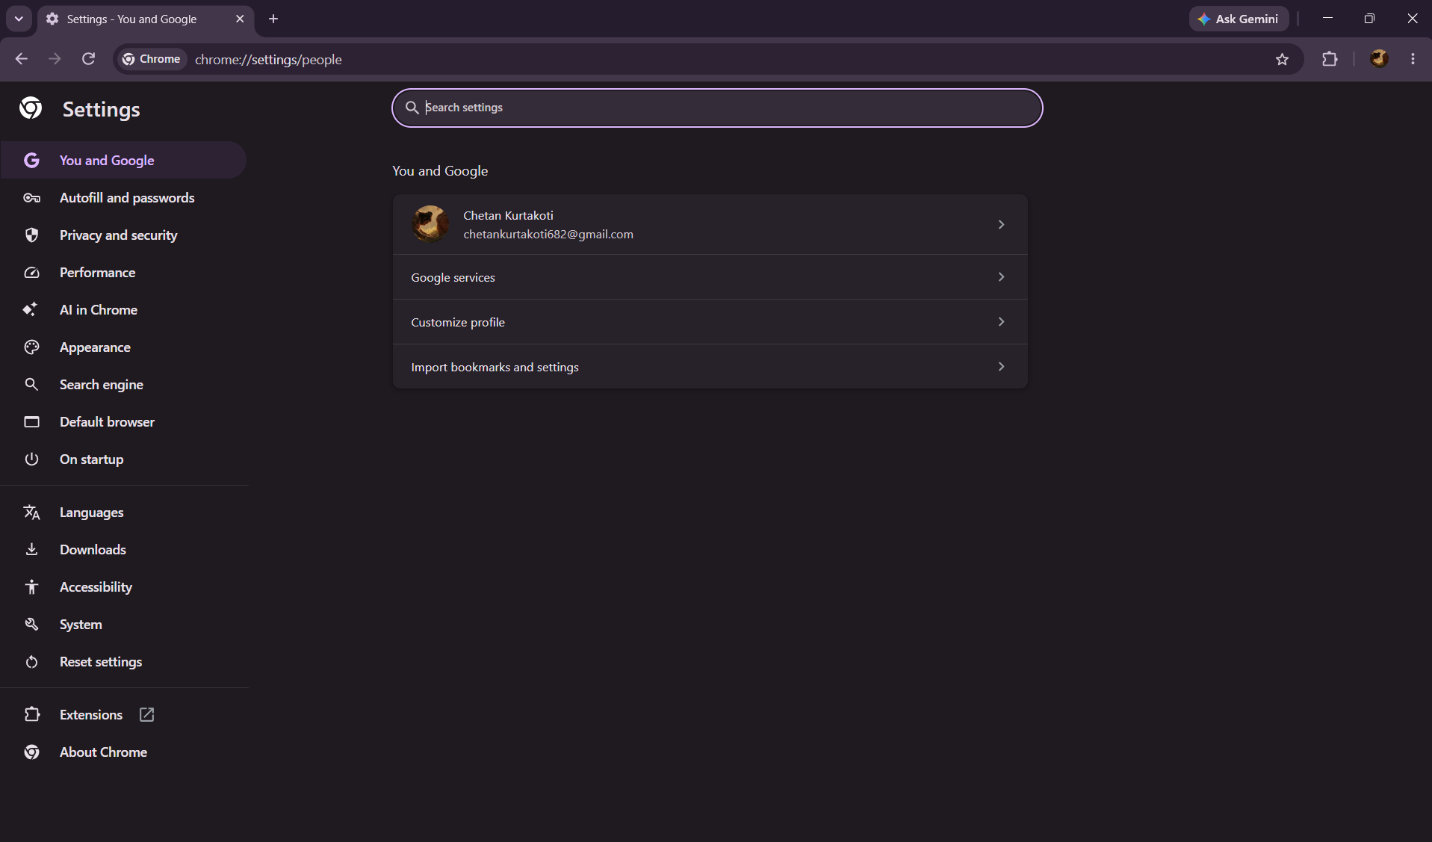
Step4: In Security->Safe browsing
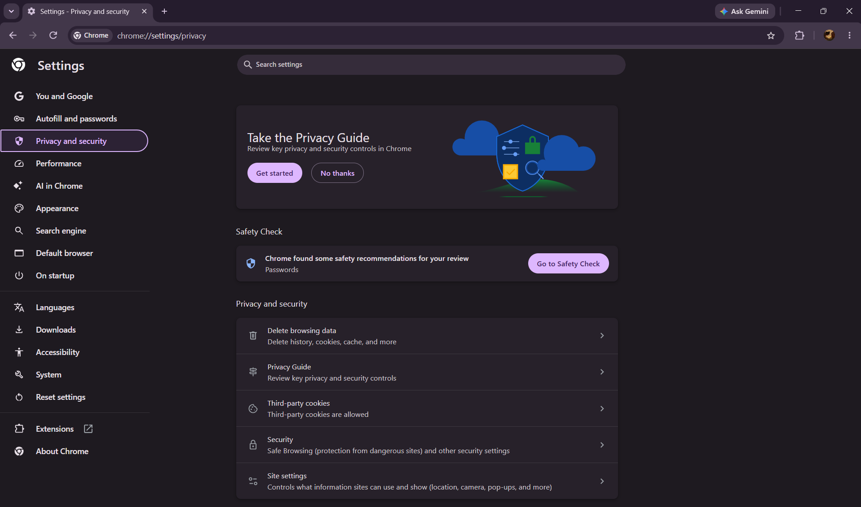
Step5:Now click on “Enhanced protection” accordingly
